Scenario – 01 – Search functionality
Weak prompt –
"Test the search feature."
Missing information –
- What to search?
- In which application to search?
- Any filters to apply in output?
- Any price range info?
- Brand info?

Weak prompt output –
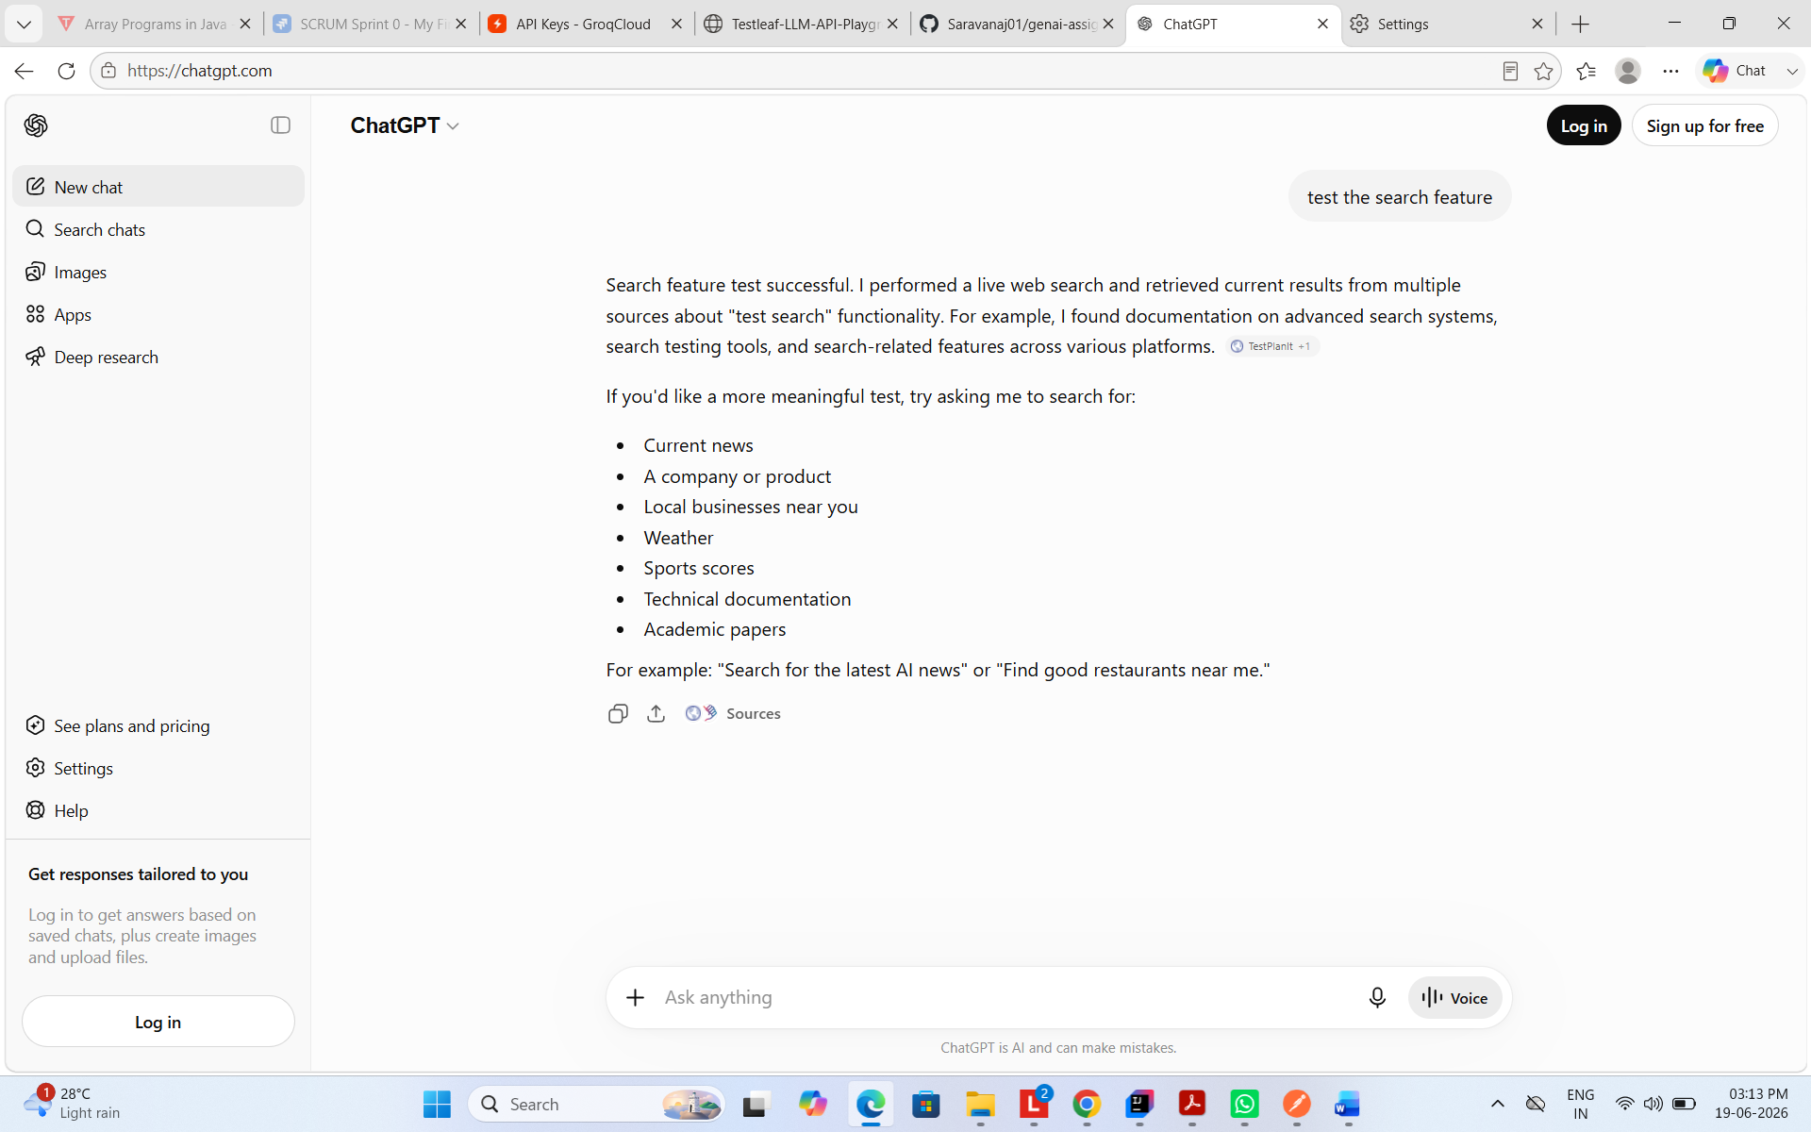

ICEPOT Prompt –
Context –
Act as a teenager who is searching for the latest model shoes in amazon website.
Instructions –
[Mandatory] Search for the Nike brand shoes for men
[Mandatory] Size of the shoe should be 7
[Strict] Show only men’s shoes
[Strict] Show only 2026 models
[Mandatory] Search only in amazon site
[High Priority] Price should be less than 5 thousand INR
[Critical] List only in stock product
[Mandatory] Product should be shipped to Bangalore - 560100

Example –
Shoe model name | Size | Price | Discount | Year make| Availability | Shipping
Output –
Give the search result in table format as given in the example.
Tone – Generate the output in friendly way and show the items which met all the above criteria.

Output –
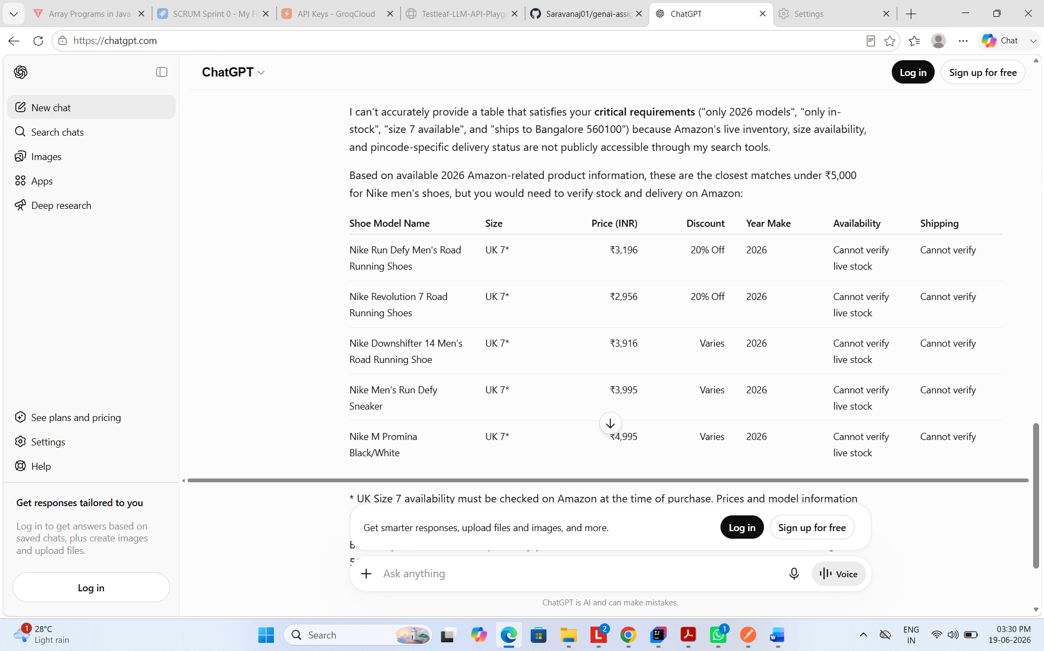
Scenario 02 – File upload
Weak prompt - "Generate test cases for file upload."
Missing information –
- Which site to upload
- Types of files to support
- Size limit for each type
- Verify success message after the successful upload
- Failure message validation
Weak prompt output –
Here are comprehensive test cases for a **File Upload** feature.

| TC ID | Test Scenario | Test Steps | Expected Result |
| ------ | ------------------------------------------------ | --------------------------------------------- | ------------------------------------------------------- |
| FU_001 | Upload a valid file | Select a supported file and click Upload | File uploads successfully |
| FU_002 | Upload multiple valid files | Select multiple supported files | All files upload successfully |
| FU_003 | Upload file with minimum allowed size | Upload a file at minimum size limit | Upload succeeds |
| FU_004 | Upload file with maximum allowed size | Upload a file at maximum size limit | Upload succeeds |
| FU_005 | Upload file exceeding maximum size | Upload a file larger than allowed limit | Error message displayed |
| FU_006 | Upload empty file (0 KB) | Upload an empty file | System handles according to requirement (accept/reject) |
| FU_007 | Upload supported file type | Upload a valid extension (e.g., PDF) | Upload succeeds |
| FU_008 | Upload unsupported file type | Upload an unsupported extension (.exe) | Upload rejected with error |
| FU_009 | Upload file with special characters in name | Upload file containing @,#,$,%,& | Upload succeeds or validation shown |
| FU_010 | Upload file with very long filename | Upload file exceeding filename length limit | Appropriate validation displayed |
| FU_011 | Upload file with spaces in filename | Upload file containing spaces | Upload succeeds |
| FU_012 | Upload duplicate file | Upload same file twice | Duplicate handling as per requirements |
| FU_013 | Cancel upload before completion | Start upload and cancel | Upload stops successfully |
| FU_014 | Remove selected file before upload | Select file and remove it | File removed from upload list |
| FU_015 | Upload corrupted file | Upload a damaged file | Proper validation/error shown |
| FU_016 | Upload password-protected file | Upload encrypted document | System handles per requirements |
| FU_017 | Upload file via drag-and-drop | Drag supported file to upload area | Upload succeeds |
| FU_018 | Upload file using browse option | Use file picker dialog | Upload succeeds |
| FU_019 | Upload file without selecting file | Click Upload without choosing file | Validation message displayed |
| FU_020 | Verify upload progress indicator | Upload large file | Progress bar/status shown correctly |
| FU_021 | Verify upload success message | Upload valid file | Success notification displayed |
| FU_022 | Verify upload failure message | Simulate failed upload | Error notification displayed |
| FU_023 | Upload file during network interruption | Disconnect network during upload | Appropriate error/retry option shown |
| FU_024 | Retry failed upload | Retry after failure | Upload completes successfully |
| FU_025 | Upload file after session timeout | Allow session to expire then upload | User prompted to re-login |
| FU_026 | Upload file with same name but different content | Upload both files | Handled correctly without overwrite issues |
| FU_027 | Verify file preview after upload | Upload preview-supported file | Preview displayed correctly |
| FU_028 | Verify uploaded file download | Upload then download file | Downloaded file matches original |
| FU_029 | Verify uploaded file deletion | Delete uploaded file | File removed successfully |
| FU_030 | Verify upload on different browsers | Test Chrome, Edge, Firefox, Safari | Consistent behavior |
| FU_031 | Verify upload on mobile devices | Upload from mobile browser | Upload succeeds |
| FU_032 | Verify upload with slow network | Upload under throttled connection | Upload handled gracefully |
| FU_033 | Verify simultaneous uploads | Upload multiple files concurrently | All uploads processed correctly |
| FU_034 | Upload file containing malware | Upload infected file | File blocked/quarantined |
| FU_035 | Upload renamed executable file | Rename .exe to .pdf and upload | Validation detects actual file type |
| FU_036 | Verify file MIME type validation | Upload file with mismatched MIME type | Upload rejected |
| FU_037 | Upload file with Unicode filename | Upload file containing non-English characters | Upload succeeds |
| FU_038 | Verify storage limit reached | Upload when quota exceeded | Appropriate error displayed |
| FU_039 | Refresh page during upload | Refresh browser while uploading | Upload handled per requirement |
| FU_040 | Verify audit/logging of upload activity | Upload file successfully | Upload event logged correctly |

### Security Test Cases

| TC ID | Test Scenario | Expected Result |
| ------- | ---------------------------------------- | -------------------------------------- |
| SEC_001 | Upload executable (.exe) file | Upload blocked |
| SEC_002 | Upload script file (.js, .bat, .sh) | Upload blocked |
| SEC_003 | Upload file with SQL injection filename | Input sanitized |
| SEC_004 | Upload file with XSS payload in filename | No script execution |
| SEC_005 | Upload malicious macro-enabled document | Security scan triggered |
| SEC_006 | Access another user's uploaded file | Access denied |
| SEC_007 | Bypass client-side validation | Server-side validation prevents upload |
| SEC_008 | Upload oversized file through API | Request rejected |

### Performance Test Cases

| TC ID | Test Scenario | Expected Result |
| -------- | ------------------------------------- | ------------------------------- |
| PERF_001 | Upload 100 files simultaneously | System remains stable |
| PERF_002 | Upload maximum size file repeatedly | Performance within SLA |
| PERF_003 | Concurrent uploads by multiple users | No degradation beyond threshold |
| PERF_004 | Measure upload response time | Meets performance requirements |
| PERF_005 | Verify storage cleanup after deletion | Resources released correctly |

These test cases cover **functional, validation, security, usability, compatibility, and performance** aspects of a file upload feature.

ICEPOT Prompt –
Context –
Act as a senior software test engineer who is writing test scripts for file upload feature in https://filebin.net/ website.
Instructions –
[Mandatory] Generate test cases for file upload feature in https://filebin.net website
[Strict] It should allow only pdf, csv and xlsx formats files to upload
[Strict] File size should not exceed 100 MB for Pdf.
[Strict] File size should not exceed 100 KB for xlsx and csv format
[High Priority] File name should not exceed 50 chars length
[Mandatory] Verify success message after upload
[Mandatory] Verify failure message on failure
[Critical] Upload time should not exceeds 1 min

Example –
TC No | Test Case Name | Pre condition| Description | Test data | Steps | Expected Result |
Output –
Give the test cases in table format as mentioned in the example.
Tone – Generate the output in professional and concise manner, focusing on the technical aspects of the upload feature.

Output :-

Below are sample test cases for the **File Upload** feature on **[Filebin](https://filebin.net?utm_source=chatgpt.com)**, based on the specified business rules and validation requirements.

| TC No | Test Case Name | Pre-condition | Description | Test Data | Steps | Expected Result |
| ------ | ----------------------------------------------------------- | --------------------------- | --------------------------------------------------- | ------------------------------------ | ------------------------------------------------------ | ------------------------------------------------------------------------------ |
| TC_001 | Upload Valid PDF File | User is on File Upload page | Verify upload of a valid PDF file within size limit | PDF, 50 MB, filename length 20 chars | 1. Open upload page 2. Select PDF file 3. Click Upload | File uploads successfully within 1 minute and success message is displayed |
| TC_002 | Upload PDF File Exactly 100 MB | User is on File Upload page | Verify upload of PDF file at maximum allowed size | PDF, 100 MB | 1. Select 100 MB PDF 2. Upload file | File uploads successfully and success message is displayed |
| TC_003 | Upload PDF File Greater Than 100 MB | User is on File Upload page | Verify validation for oversized PDF | PDF, 101 MB | 1. Select file 2. Upload | Upload fails and appropriate failure message is displayed |
| TC_004 | Upload Valid CSV File | User is on File Upload page | Verify upload of CSV file within size limit | CSV, 50 KB | 1. Select CSV file 2. Upload | Upload succeeds and success message is displayed |
| TC_005 | Upload CSV File Exactly 100 KB | User is on File Upload page | Verify upload of CSV at maximum allowed size | CSV, 100 KB | 1. Select CSV file 2. Upload | Upload succeeds and success message is displayed |
| TC_006 | Upload CSV File Greater Than 100 KB | User is on File Upload page | Verify validation for oversized CSV | CSV, 101 KB | 1. Select CSV file 2. Upload | Upload fails and failure message is displayed |
| TC_007 | Upload Valid XLSX File | User is on File Upload page | Verify upload of XLSX file within size limit | XLSX, 80 KB | 1. Select XLSX file 2. Upload | Upload succeeds and success message is displayed |
| TC_008 | Upload XLSX File Exactly 100 KB | User is on File Upload page | Verify upload of XLSX at maximum allowed size | XLSX, 100 KB | 1. Select XLSX file 2. Upload | Upload succeeds and success message is displayed |
| TC_009 | Upload XLSX File Greater Than 100 KB | User is on File Upload page | Verify validation for oversized XLSX | XLSX, 101 KB | 1. Select XLSX file 2. Upload | Upload fails and failure message is displayed |
| TC_010 | Upload Unsupported TXT File | User is on File Upload page | Verify only supported formats are accepted | TXT, 10 KB | 1. Select TXT file 2. Upload | Upload is rejected and failure message is displayed |
| TC_011 | Upload Unsupported JPG File | User is on File Upload page | Verify unsupported image file upload restriction | JPG, 50 KB | 1. Select JPG file 2. Upload | Upload is rejected and failure message is displayed |
| TC_012 | Upload File With Filename Length Exactly 50 Characters | User is on File Upload page | Verify filename length boundary | PDF with filename length = 50 chars | 1. Select file 2. Upload | Upload succeeds and success message is displayed |
| TC_013 | Upload File With Filename Length Greater Than 50 Characters | User is on File Upload page | Verify filename length validation | PDF with filename length = 51 chars | 1. Select file 2. Upload | Upload fails and failure message is displayed |
| TC_014 | Upload File With Special Characters In Filename | User is on File Upload page | Verify handling of special characters | report_2026@#$.pdf | 1. Select file 2. Upload | System validates filename as per specification and displays appropriate result |
| TC_015 | Upload Empty PDF File | User is on File Upload page | Verify upload of empty file | PDF, 0 KB | 1. Select file 2. Upload | System displays success or validation message as per requirements |
| TC_016 | Upload Multiple Supported Files | User is on File Upload page | Verify multiple file upload functionality | PDF 10 MB, CSV 50 KB, XLSX 80 KB | 1. Select multiple files 2. Upload | All valid files upload successfully within 1 minute |
| TC_017 | Verify Success Message Content | Successful upload completed | Verify upload confirmation message | Valid PDF | 1. Upload valid file | Success message is displayed with correct content |
| TC_018 | Verify Failure Message Content | Upload validation fails | Verify failure notification | PDF 150 MB | 1. Upload invalid file | Appropriate failure message is displayed with reason |
| TC_019 | Verify Upload Time For PDF | User is on File Upload page | Verify upload performance requirement | PDF, 100 MB | 1. Start upload 2. Measure completion time | Upload completes within 60 seconds |
| TC_020 | Verify Upload Time For CSV | User is on File Upload page | Verify upload performance for CSV | CSV, 100 KB | 1. Upload file 2. Measure time | Upload completes within 60 seconds |
| TC_021 | Verify Upload Time For XLSX | User is on File Upload page | Verify upload performance for XLSX | XLSX, 100 KB | 1. Upload file 2. Measure time | Upload completes within 60 seconds |
| TC_022 | Upload Without Selecting File | User is on File Upload page | Verify mandatory file selection validation | No file | 1. Click Upload without selecting file | Validation message is displayed |
| TC_023 | Network Interruption During Upload | Upload in progress | Verify failure handling during connectivity loss | PDF 50 MB | 1. Start upload 2. Disconnect network | Upload fails gracefully and failure message is displayed |
| TC_024 | Upload File With Wrong Extension But Valid MIME Content | User is on File Upload page | Verify file type validation | PDF renamed as TXT | 1. Upload file | System validates file type correctly and rejects invalid extension |
| TC_025 | Verify Concurrent Upload Stability | User is on File Upload page | Verify system behavior during multiple uploads | Multiple valid files | 1. Upload files simultaneously | All uploads are processed successfully without performance degradation |

### Coverage Summary

* ✅ Supported file types: PDF, CSV, XLSX
* ✅ Unsupported file type validation
* ✅ File size boundary testing
* ✅ Filename length boundary testing
* ✅ Success and failure message validation
* ✅ Performance validation (upload time ≤ 1 minute)
* ✅ Multiple upload scenarios
* ✅ Negative and error-handling scenarios
* ✅ Boundary value and robustness testing

Scenario 3 :- Shopping cart
Weak prompt –
"Test the cart functionality"
Missing information –
- What items add?
- In which application to test?
- Add/remove/delete functionality?
- Price calculation?
- Item Limits?
- Any Discounts?
- In stock/out of stock products
Weak prompt output –
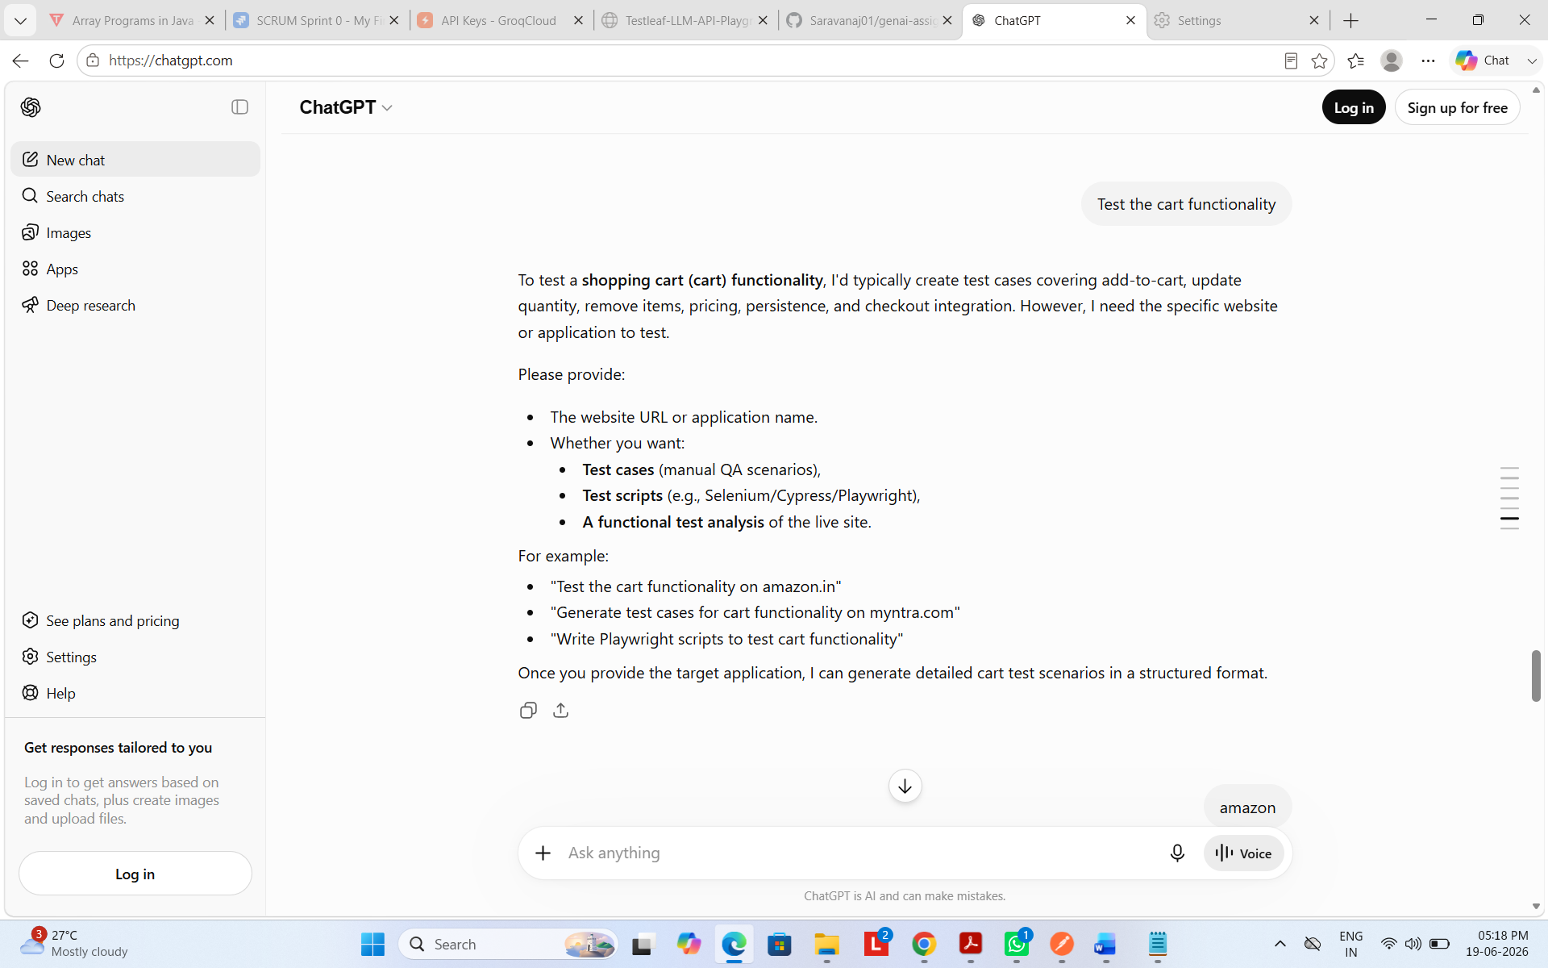

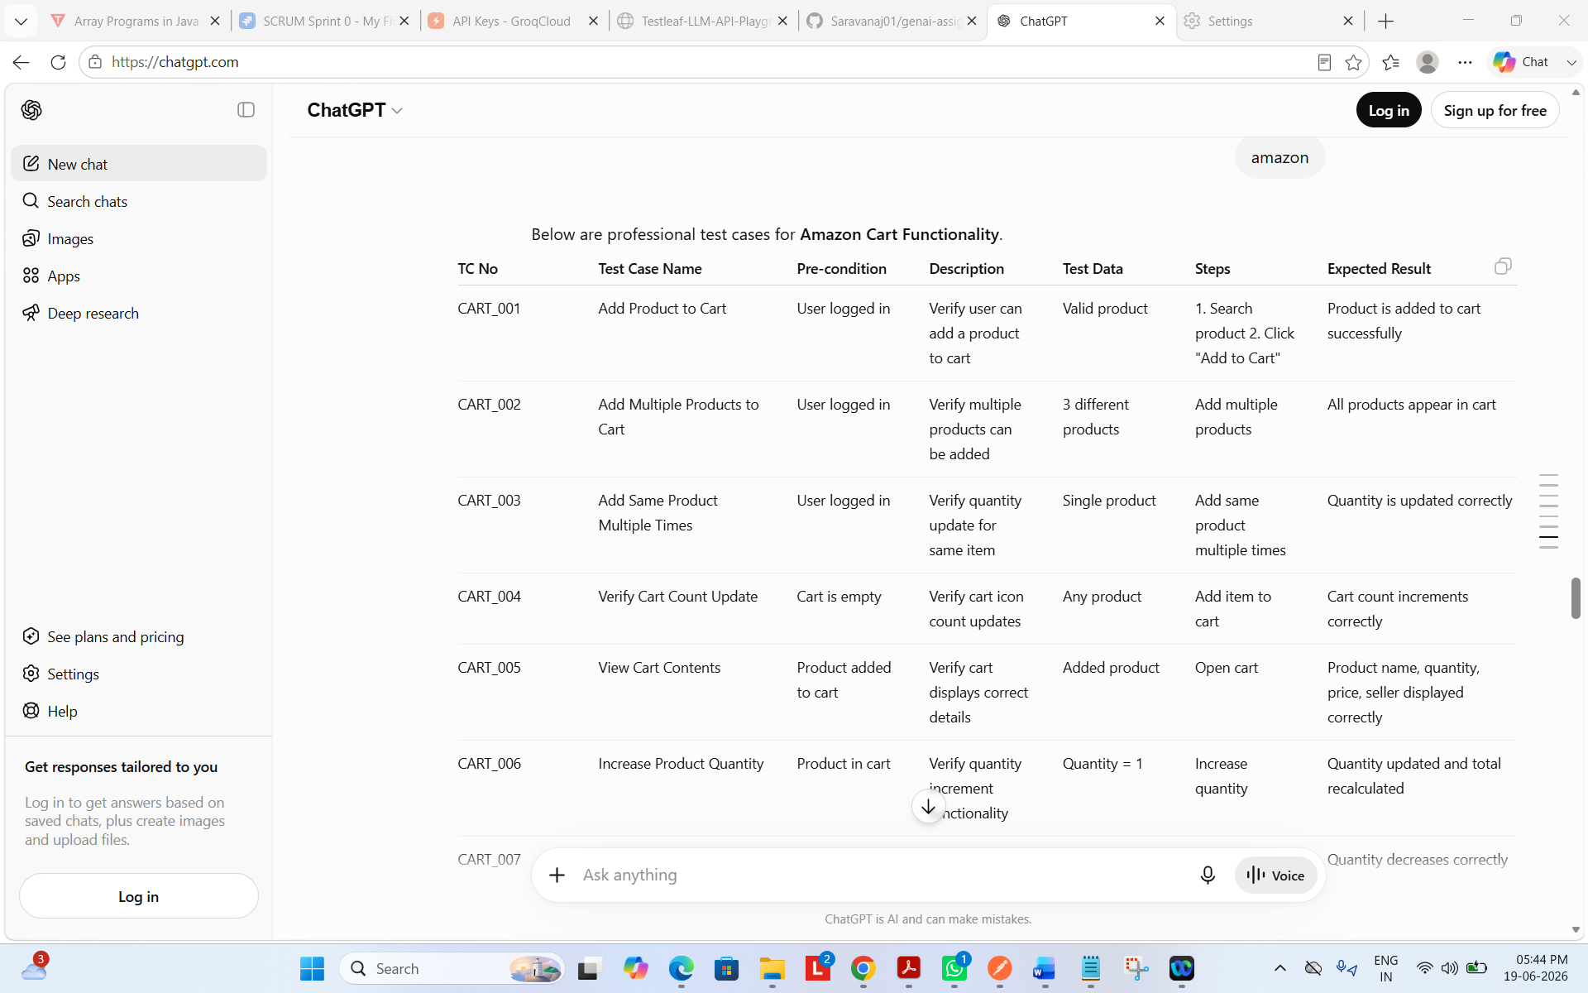
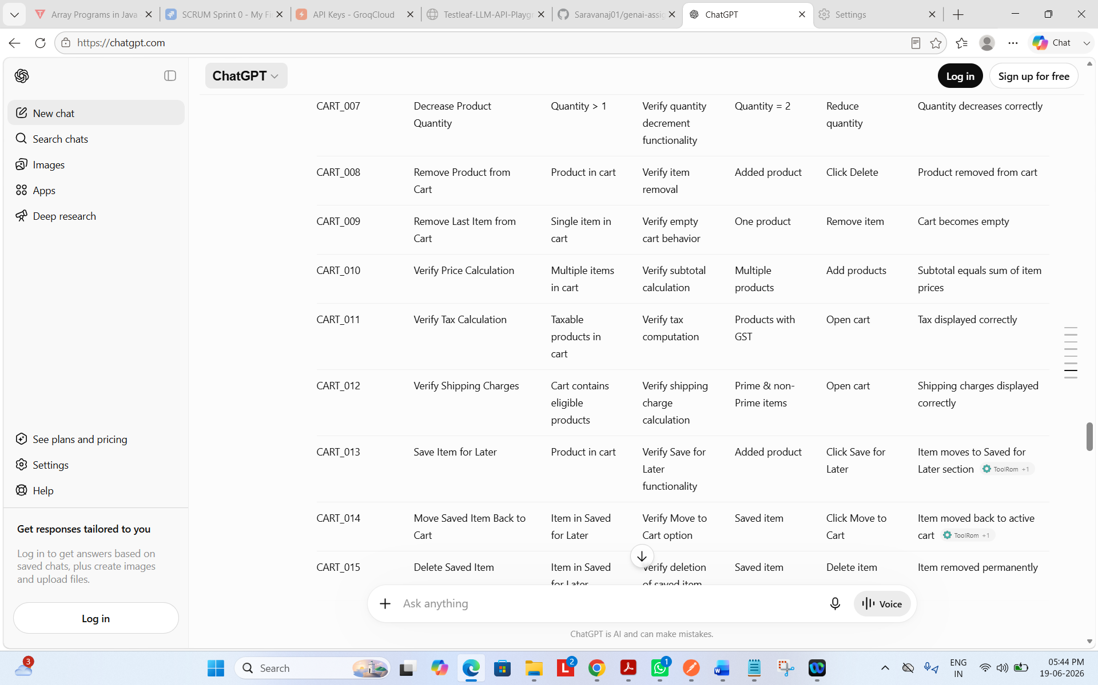
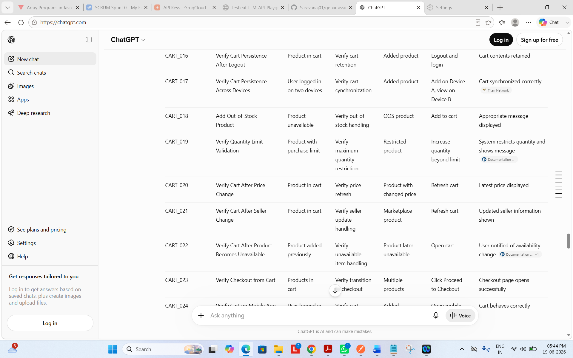
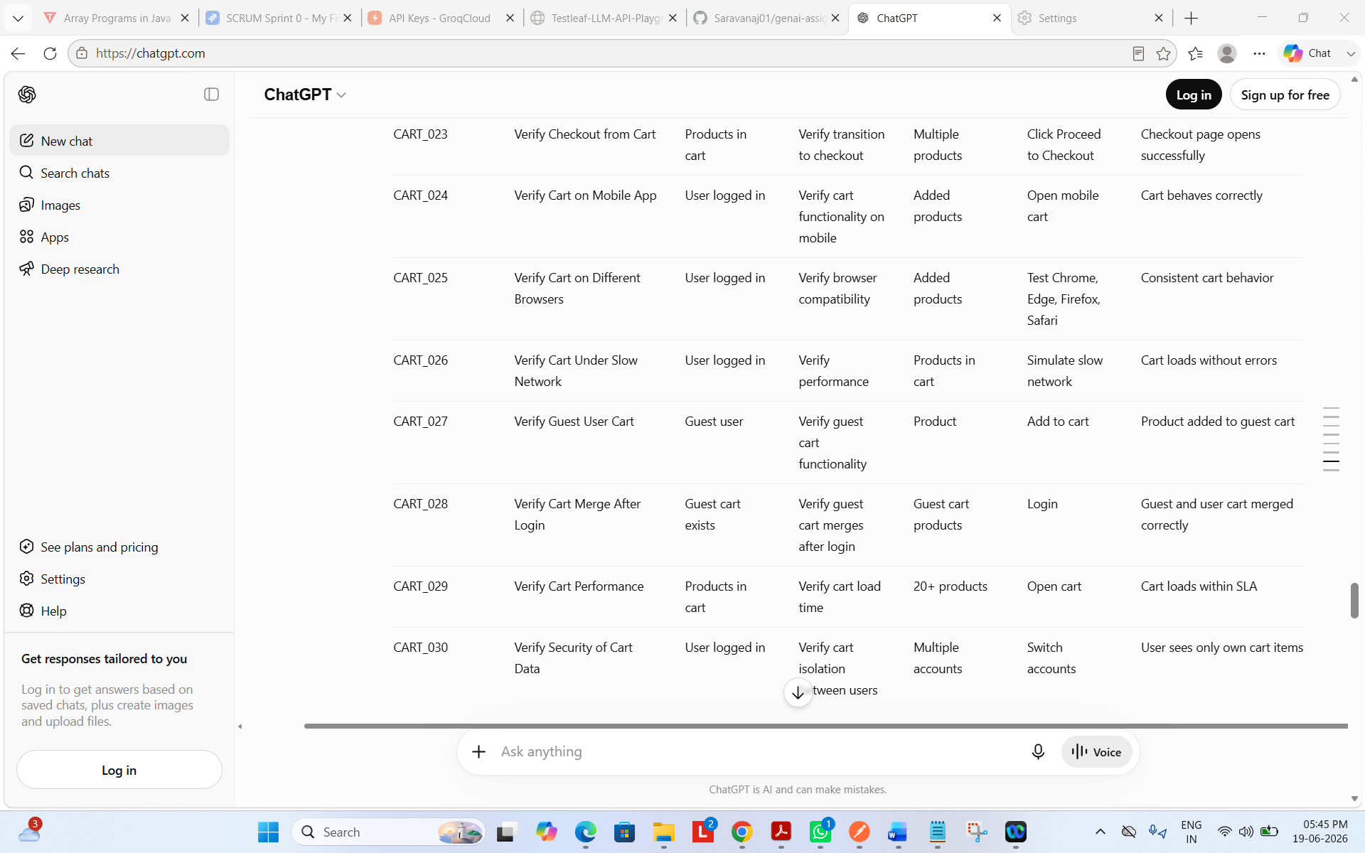
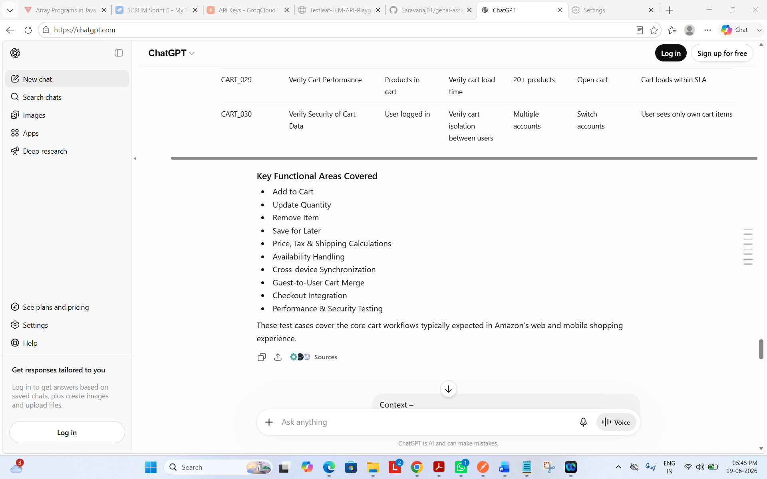

ICEPOT Prompt –
Context –
Act as a senior software test engineer who is writing test scripts for Shopping cart feature in amazon website.
Instructions –
[Mandatory] Generate test cases for cart functionality in amazon website
[Strict] Add items and verify the data in cart
[Strict] Remove items and verify the data in cart
[Strict] Add multiple items and verify the data in cart
[High Priority] Apply coupons and verify the price is calculated based on that
[Mandatory] Verify success message after adding, removing cart
[Mandatory] Verify failure message on failure
[Critical] Verify save later and add to add flow

Example –
TC No | Test Case Name | Pre condition| Description | Test data | Steps | Expected Result |
Output –
Give the test cases in table format as mentioned in the example.
Tone – Generate the output in professional and concise manner, focusing on the technical aspects of the shopping cart feature.

Output :-

